Trương Quốc Bảo 21017351

Thực hành docker-compose-file

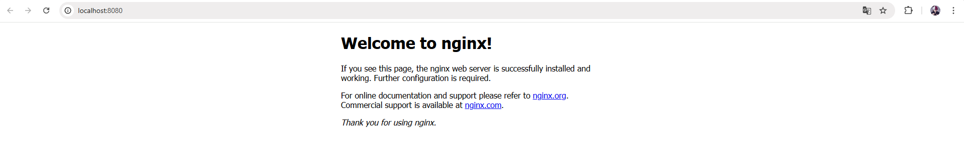

Câu 2+3

Bài 4

Bài 5

Bài 6

Bài 7

Bài 8